CS 255 System Design Document Template

This template lays out all the different sections that you need to complete for Project Two. Each section has guidance to prompt your thinking. You will need to continually reference the interview transcript as you work to make sure that you are addressing your client’s needs. There is no required length for the final document. Instead the goal is to complete each section based on what your client’s needs are. Remove this note when you are finished, and replace all bracketed text with the relevant information.

UML Diagrams

UML Use Case Diagram
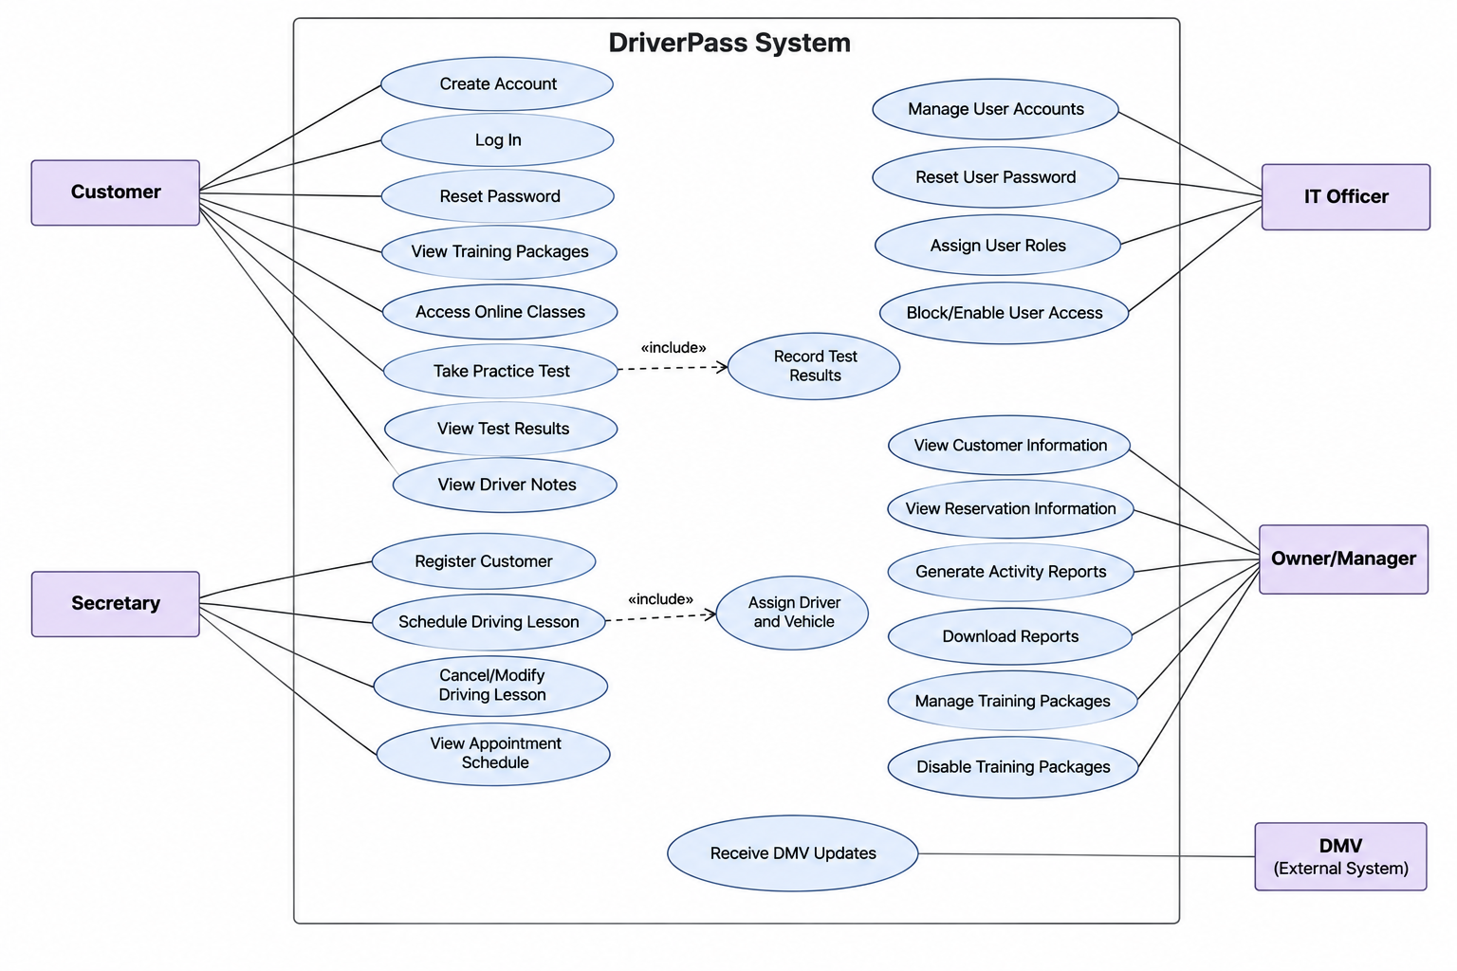

UML Activity Diagrams

Activity Diagram 1: Schedule a Driving Lesson
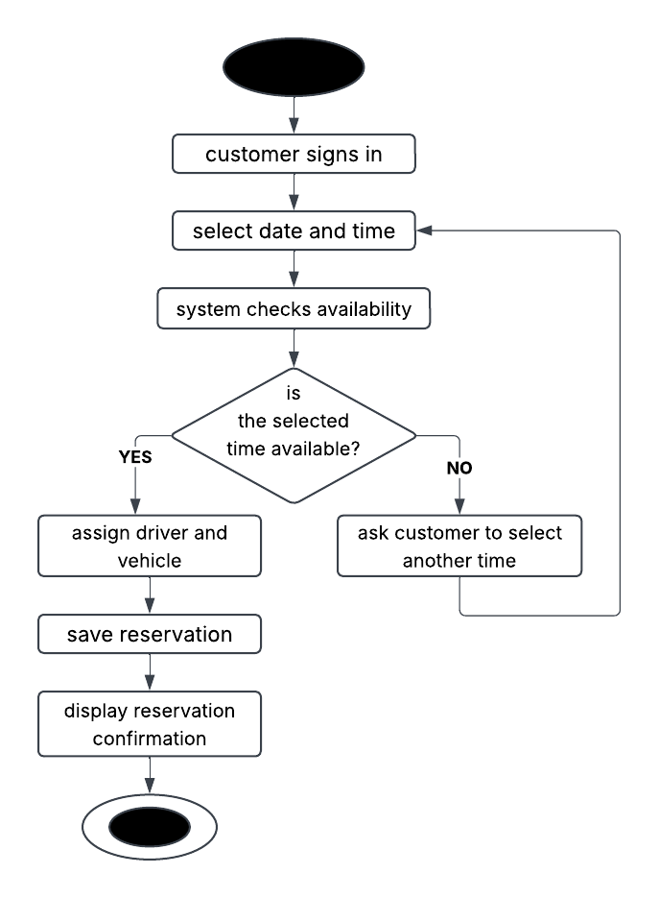
Activity Diagram 2: Take an Online Practice Test
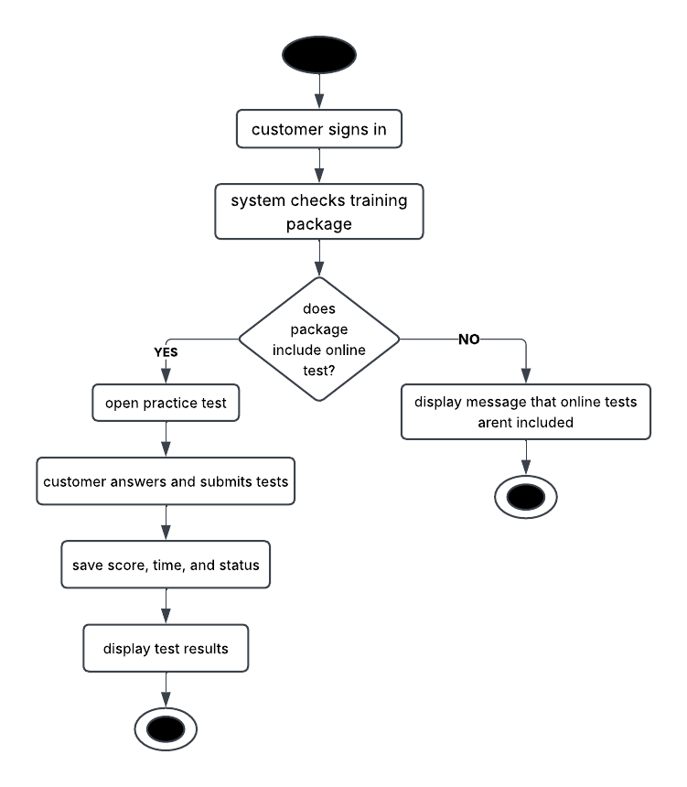

UML Sequence Diagram
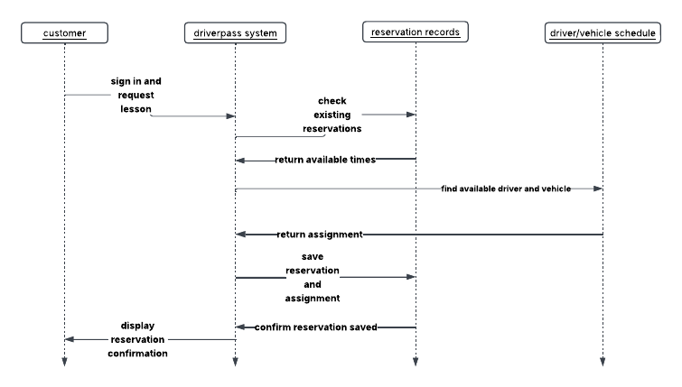

UML Class Diagram
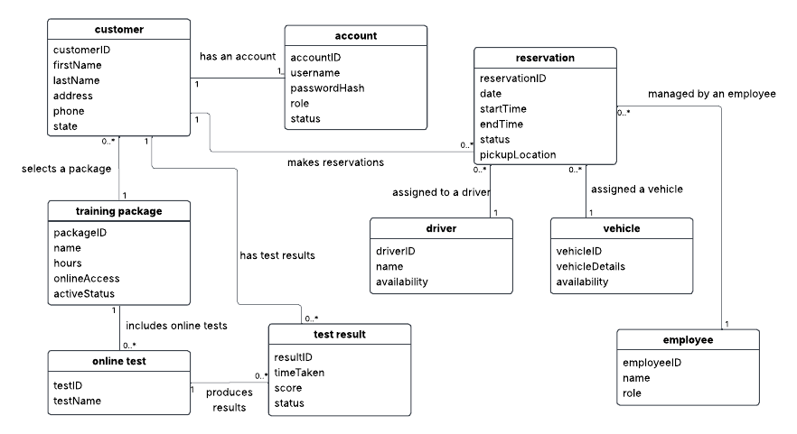

Technical Requirements
need reliable backup and recovery services to protect its information and restore data if a technical issue occurs.

Software Requirements
The system will use a web-based application that customers and employees can access through a modern web browser. A database will store customer information, account details, reservations, driver and vehicle assignments, training packages, and online test results. The system should also support downloadable reports in a format compatible with Microsoft Excel. Online learning materials and practice tests must be available to customers whose training packages include those features.

Development Tools
The development team will use UML diagrams to plan and document the system's structure and behavior. Lucidchart can be used to create the use case, activity, sequence, and class diagrams. Appropriate programming tools, database software, and testing tools will be selected to develop, test, and maintain the application.

Security and Infrastructure
The system must require users to sign in and use role-based permissions to restrict access to authorized features. The IT officer must be able to reset passwords, manage accounts, and block access when necessary. The system should maintain an activity history of important actions, including reservation creation, cancellation, and modification. Secure connections, protected password storage, regular backups, and appropriate data access controls will help protect customer information. The system should also support receiving updates from the DMV about driving rules, policies, and practice questions.

